



**ECTU REDCap Database Development Guide**

[**https://redcap.clinicaltrials.ed.ac.uk/**](https://redcap.clinicaltrials.ed.ac.uk/)

|  |
| --- |
| **Introduction** |

This document provides guidance on developing a study database on the REDCap platform. This document is for guidance only and some sections may not apply or may differ depending on the study requirements.

This guidance is for use with the current ECTU REDCap SOPs which are available on the ECTU shared drive.

|  |
| --- |
| **Creating a new study database** |

The ability to create a new study database is contigent on the access rights attached to users profile. Users must either being assigned the right to create new projects when the profile is created by an Administrator or the user must be an Administrator themselves in order to create a new study database.

A new study database is created by clicking ‘New Project’ at the top of the main dashboard:



This will open the following form to complete:

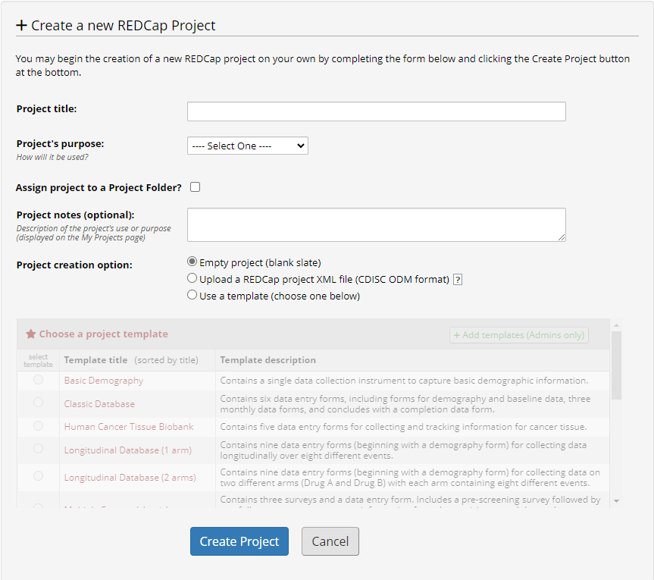

Sections should be completed as follows:

**Project title:** STUDY NAME/ACRONYM Training – Do NOT enter live data onto this database

The initial version of the database created will be a training version. The project title should clearly specify this using the naming convention above.

**Project’s purpose:** Research

**Assign project to a Project Folder? :** This does not need to be ticked. If the user has an existing folder structure and they would like to assign the project accordingly, this may be ticked and the folder selected as required.

**Project notes (optional):** This does not need to be completed

**Project creation option:** Ensure ‘Empty Project (blank slate)’ is selected.

Once the form is complete, click ‘Create Project’ to add the project to the main dashboard.

|  |
| --- |
| **Initial Project Set-up** |

Most core functionality for the database can be accessed from the ‘Project Setup’ page:

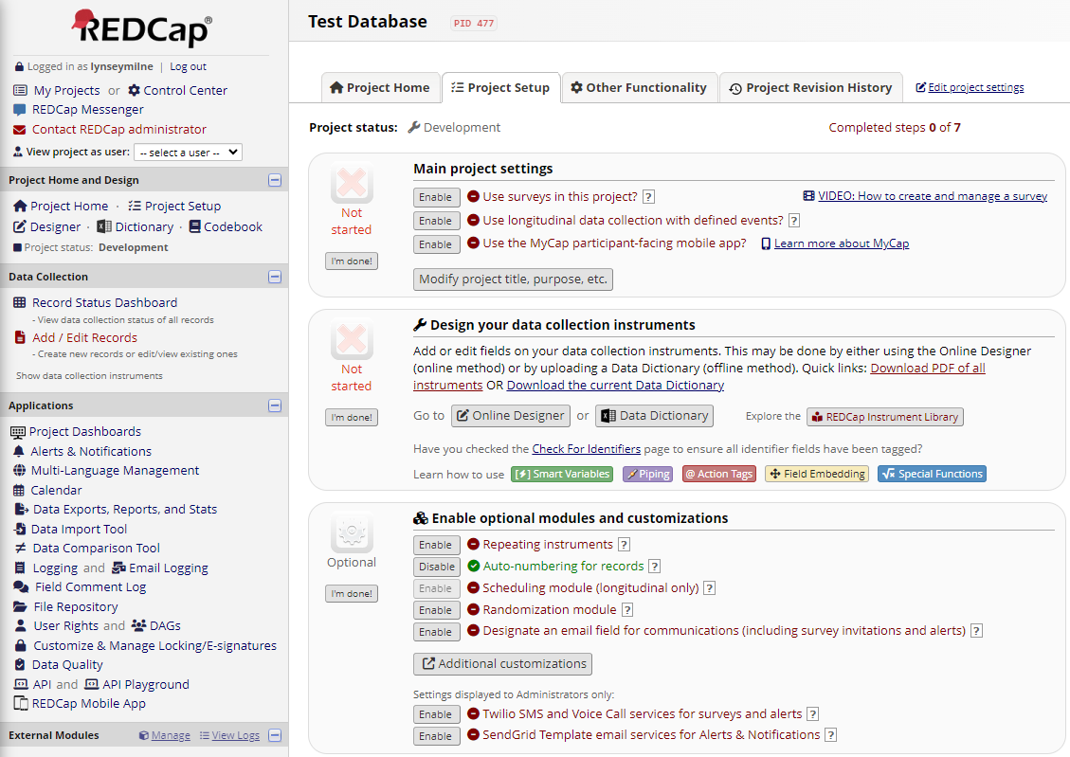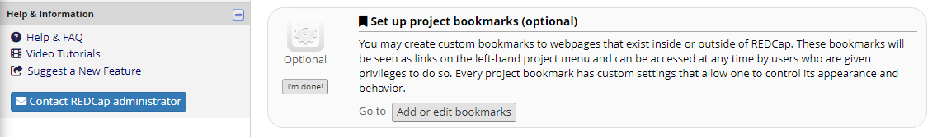

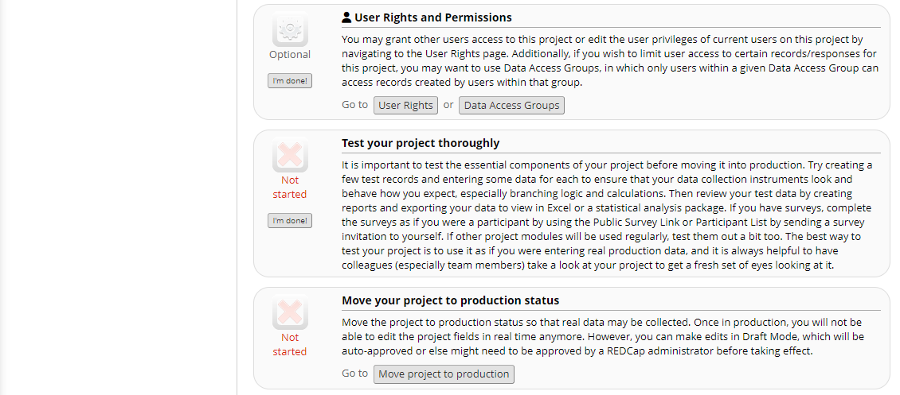

Settings can be enabled as required but the most commonly used are:

* **‘Use surveys in this project?’** – This should be enabled if online completion of surveys is required for the study.
* **‘Use longitudinal data collection and defined events?’** – This should be enabled if the study has defined timepoints (events) and will commonly use the same instruments over the different events. This is commonly used in most study databases .
* **‘Repeating instruments’** – This should be enabled if you expect certain instruments or events to be completed more than once. This is commonly used for Adverse Event or Concomitant Medication instruments where several instances of the same form may be recorded.
* **‘Auto-numbering for records?’** – This setting will be enabled as a default. This means that REDCap will automatically number each record when it is added to the database. If disabled, the user will enter the record number or identifier when they add the record. It is recommended that auto-numbering is used as much as possible.

|  |
| --- |
| **User Management and Roles** |

Once the project is created, the person who created the project will be added as a user by default. They will automatically have top-level access to the study database. Administrators will also have top-level access to the database. All other users must be added to the database manually to the appropriate user role.

User roles are created in the ‘User Rights’ section, accessed via the ‘Project Setup’ page or in the ‘Applications’ list. The following user roles are common to most study databases (titles/functions changeable as per study requirements):

**Site Data Entry/Site Researcher**

* Access to calendar and file repository
* Access to respond to open queries
* Access to create records
* View and edit access to all applicable instruments
* If surveys, access to edit survey responses
* No access to Site PI only instruments (e.g. CRF Sign-Off) if applicable

**Site PI**

* Access to calendar and file repository
* Access to respond to open queries
* Access to create records
* View and edit access to all applicable instruments
* If surveys, access to edit survey responses
* Access to designated Site PI only instruments (e.g. CRF Sign-Off) if applicable

**Trial Office**

* Access to add users to the study database
* Access to add/edit/organise reports (unless concerns about blinding)
* Access to calendar and file repository
* Access to execute data quality rules
* Access to respond to open queries (unless managing data quality themselves, i.e. external TMs)
* Access to create records
* Read only access to all instruments

**Monitor**

* Access to execute data quality rules
* Read only access to all instruments
* Access to Logging

**Unblinded Statistician**

* Access to data export only
* No access to instruments or any other features of REDCap

**API (only for databases using API for Randomisation or Text Alerts)**

* Access role for user ectu.redcap only
* Used to facilitate the API token for external randomisation or text alerts

**Data export rights should be limited to unblinded statisticians and REDCap administrators unless exceptional circumstances or approved by statistician.**

User management on REDCap is a two-fold process. First, users must be given access to the REDCap platform. This can only be done by those with correct Administrator access. Once REDCap access has been given, access to the study database can be given by users allocated to the Trial Office (or similar) user role. NOTE: Study database user access may not always be delegated to trial staff. In some cases, REDCap Administrators may assign both REDCap and study database access.

Users in the Site Data Entry/Site Researcher or Site PI roles will also be assigned to specific DAG (see section 5 below) once they are added. This means they only be able to add and access records for that particular site and no others.

Users in all other roles, are not assigned to a specific site.

|  |
| --- |
| **Data Access Groups** |

Data Access Groups (DAGs) are study sites. DAGs are created via the ‘DAG’s’ section in the Applications list or via ‘Data Access Groups’ in Project Setup.

The list of DAGs participating in the study will be provided by the Trial Manager or designee. The DAG should be names using the site name (e.g. Royal Infirmary Edinburgh) and can also include a site number if preferred.

Once the DAG has been created, a unique identifier will be automatically generated by REDCap for that DAG. If the study is using auto-numbering for the record identifier, this number will form part of that identifier. For example, DAG added for Site 1 – Royal Infirmary Edinburgh has unique identifier of 1234. This means that the first record added by a user for that site will be 1234-1, and the second 1234-2 and so on.

It is recommended that all study databases have a DAG assigned, even if a single site study. If the project later decides to expand, it is easy to add additional DAGs but not easy to add a new DAG for the first time (all existing participant records will need to be manually assigned).

|  |
| --- |
| **Event Structure** |

Events are used to define the timepoints and schedule of the study. In order to define events, longitudinal data collection must be enabled (see section 3 Initial Project Set-up). This will display the events options on the Project Set-up page:

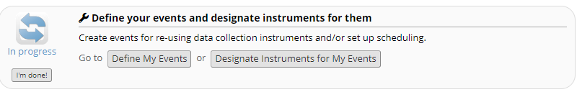

Click on ‘Define My Events’ to specify your event structure in this section below:

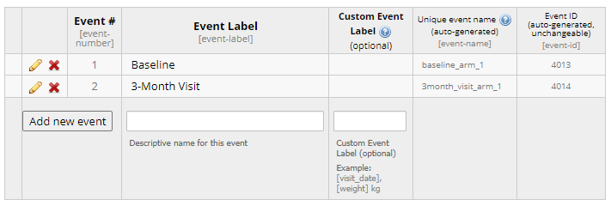

A unique event name will be automatically assigned when an event is added. This is used for Branching Logic (see section 8)

The general event structure will be defined in the schedule of assessments in the protocol and the database should reflect this.

When defining the events, consider the timings of assessments and when data will be collected/entered. Events can be split if completed over different timepoints, e.g. Pre-Randomisation, Randomisation, Post-Randomisation.

**NOTE: Once the events defined, it is NOT recommended that any changes are made to names of the events. Changing the event name may result in a loss of data that cannot be recovered.**

|  |
| --- |
| **Online Designer** |

Data collection instruments are used to add the fields and functions required as specified in the protocol or on the pCRF/data collection sheets (if provided) and are built using the ‘Online Designer’ section. This is accessible in the ‘Design your data collection instruments’ section in the Project Set-up page:

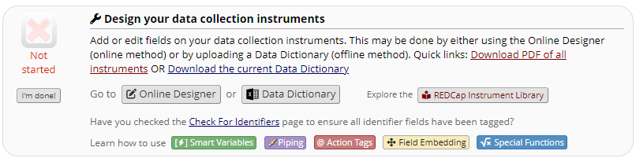

It can also be accessed via the ‘Designer’ link in the sidebar on the main dashboard:

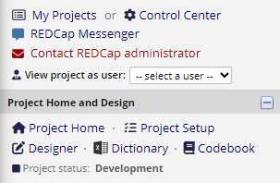

The ‘Online Designer’ will initially look like this:

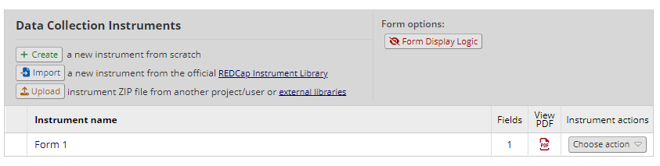

‘Form 1’ is the first instrument in your study database. The name of the instrument can be changed as appropriate (click ‘Rename’ in the ‘Choose action’ drop-down).

This instrument includes the Record ID field. This field cannot be moved or deleted and therefore this instrument must remain the first instrument of the study database.

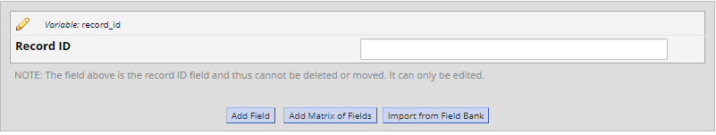

This field can be edited but only the label of this field should be changed. A field can be edited by clicking the pencil icon. The field label can be changed to an appropriate identifier for the study (e.g Participant Id instead of Record ID) but the variable name should NOT be changed. This is because any potential randomisation via an API token will use the variable ‘record_id’ to identify the participant record.

Only the field label is visible on the front-end of the database. Variable names cannot be seen at the point of data entry.

New instruments can be added by clicking ‘Create’ and selecting where the instrument should go. The flow of instruments on this page will be reflected on the main dashboard.

New instruments should be named appropriately as per the protocol or pCRF/data collection sheets (if provided).

**Adding fields to an instrument**

There is no limit to the amount of fields that can be added within an instrument but consideration should be made to the overall length of the instrument from a data entry perspective. It may be appropriate to split an instrument into smaller, separate sections with signposting provided in order to minimise the length of the page.

A field is added by clicking ‘Add Field’ at the bottom of an existing field. This will open the dialogue box as below:

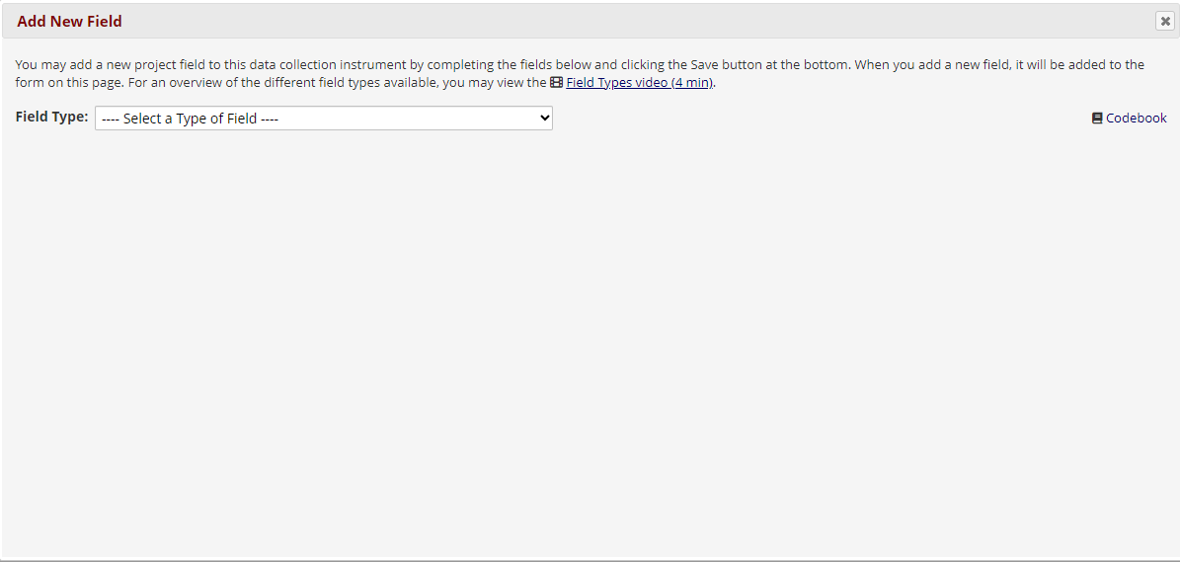

Select the ‘Field Type’ from the drop-down. A particular type of field may have been requested by the TM/Research Team in some cases but generally this is selected at the discretion of the developer. A ‘Field Label’ and ‘Variable Name’ will always be required regardless of the type of field but all other functionality can be set depending on the type selected.

If the field type is ‘Text Box’, this will add a simple free-text box allowing any type of data to be entered. It is recommended that free-text boxes are used very minimally within a study as these can be of little value to the statistician for analysis. Where possible, additional field validation should be set on any ‘Text Box’ field in order to limit it’s functionality. Additional field validation includes:

* **Date/Time Fields** – The text box will be converted to a date and/or time field (D-M-Y, HH:MM). Further validation can be added by specifying the maximum range as ‘Today’ (for date only field) or ‘Now’ (for date and/or time field) to avoid future dates/times being entered
* **Email** – The text box will only accept an email format
* **Integer** – The text box will only accept a whole number
* **Number** – The field will only accept a numerical format
* **Number (up to 4 decimal place)** – The field will only accept a number with the specified number of decimal places

**Variable Names**

The ‘record_id’ is the only field variable that should remain unchanged. All other field variable names are assigned by the developer when the field is added.

Avoid using names with numbers only unless absolutely necessary. This particularly applies to eligibility criteria which should be named with a description of the field, e.g. *Participants greater than 18 years old* should be labelled as [incl_age] or similar and not [incl_1].

Variable names should be as descriptive as possible but within the 26 character limit. Anything over 26 characters is truncated by REDCap when exporting to SAS and other stats packages so keep variable names below this.

**Required Fields**

A field can be set to ‘Required’ when it is added to the database. This means that when a page is saved and a ‘Required' field is not completed, an automated alert will trigger advising the user that this is missing.

**NOTE: Non-completion of a ‘Required’ field does not prevent a record from being saved, it simply triggers the alert as above.**

This is commonly used for Inclusion/Exclusion Criteria or fields that must be completed for randomisation. It is recommended that this is only used for selected important fields and not throughout the entire study database.

**Identifier Fields**

A field can be set as an ‘Identifier’ field when it is added to the database. This is commonly used for fields such Name, DOB, CHI Number etc. that includes personal information.

Setting an identifier field is useful when setting data export access for the instruments.

**Coding of Multiple Choice Fields**

If the ‘Field Type’ is ‘Multiple Choice – Drop-down List (Single Answer)’ or ‘Multiple Choice – Radio Buttons (Single Answer)’ or ‘Checkboxes (Multiple Answers)’, the answer options are specified in the ‘Choices’ section as below:

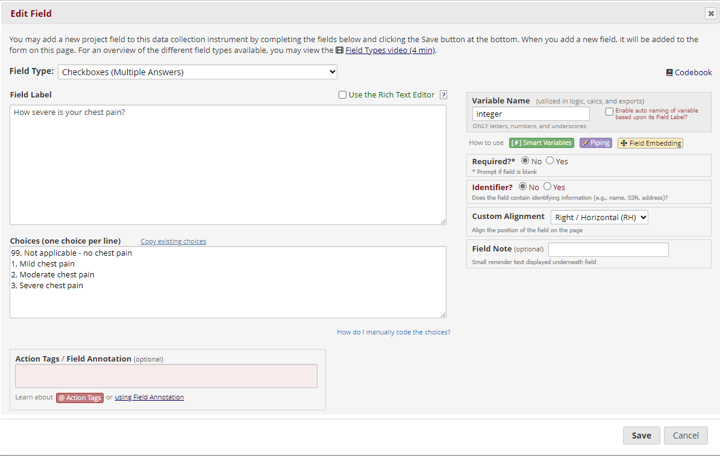

The choices will be automatically coded in numerical, sequential format (assigned at the beginning of the option). Coding can changed/assigned by the developer (as in the example above) and it is recommended that this is kept to a uniform standard throughout the database. For example, if ‘Not applicable’ or ‘N/A’ is a frequently used option and coding of ‘99’ is assigned, this should be used for all ‘N/A’ options in the study.

**NOTE:** Do not use ‘00’ as a code. This will default to ‘0’ when exported to stats packages and may make it difficult to differentiate between other choices coded with ‘0’

**Designating Instruments to Events**

Once an instrument has been built, it should be assigned to the appropriate Event. This is done via the Project Set-up page in ‘Define your events and designate instruments for them’ by clicking on ‘Designate Instruments for My Events’



This will display the list of instruments built and the events created:

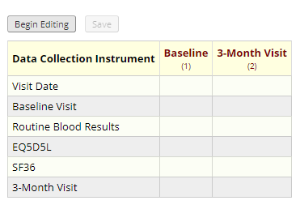

Click ‘Begin Editing’ to assign an instrument to a specific event. If an instrument is applicable at multiple events, it can be assigned on more than one event. This means the same instrument will appear at both events (it is not necessary to build the same instrument multiple times to accommodate this).

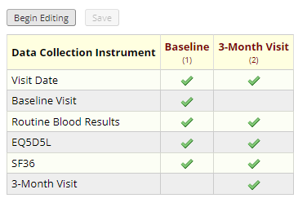

The green tick indicates that the instrument will appear at that event on the main dashboard as below:

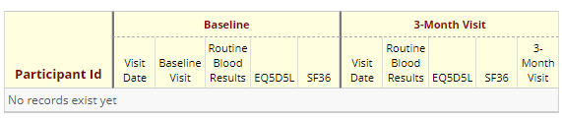

**NOTE:** Care should be taken when instruments appear over multiple events that all instances are identical. It may appear that an instrument is the same over all events but slight differences may exist (e.g. slight differences in text, additional fields, different fields). Allocating an instrument over multiple events will repeat the exact same instrument and whilst it is possible to accommodate slight differences with branching logic within the instrument, it may prove complicated and difficult to manage throughout the study. In this case, it may be advisable to build different instruments and allocate them to their events separately.

|  |
| --- |
| **Branching Logic and Form Display Logic** |

Branching Logic can be applied to fields to dictate when they appear to the user at the point of data entry. Branching Logic can be straightforward between fields within an instrument or more complex between different instruments and events.

Branching Logic is applied by referencing the event and variable name on a field as well as the coding or logic for the answer to that particular field. An example of simple branching logic is below:

Top-line question is ‘Do you have chest pain?’ (variable name: chest_pain) in the field below:



The subsequent question, ‘If Yes, how severe is the pain?’ (variable name: chest_pain_severity) in the field below:

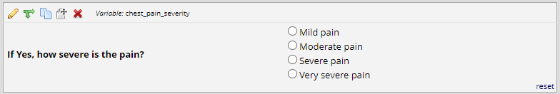

The subsequent question should only appear if the top-line question is answered ‘Yes’ so we would therefore apply the Branching Logic to the subsequent question. This is done by clicking the green arrow in the field. This opens the dialogue box below:

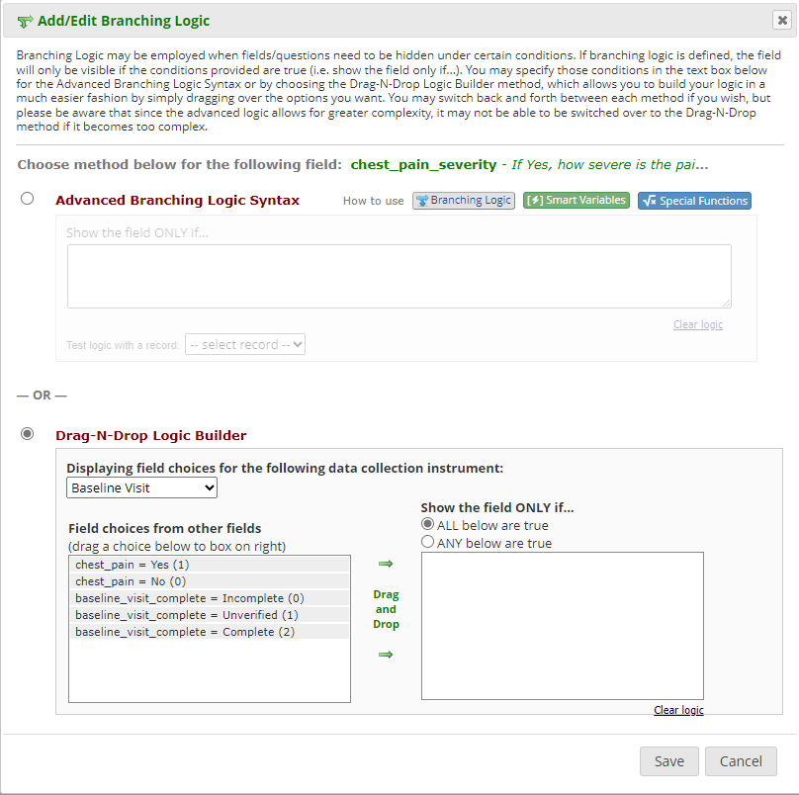

For simple Branching Logic, the ‘Drag-N-Drop Logic Builder’ can be used. This allows you to select the field choice appropriate to the logic required. In this case, ‘chest_pain = Yes (1)’ should be selected and dragged to the ‘Show the field ONLY if…’ section. This set’s the logic that the subsequent question will only appear if the top-line question is answered ‘Yes’ (1 is the coding set to this answer on the field)

The Branching Logic appears at the top of the subsequent field (and in the ‘Advanced Branched Logic Syntax’) as [chest_pain] = ‘1’, signifying that if field with variable name chest_pain is answered has answer 1 selected, this field will appear.

‘Advanced Branched Logic Syntax’ is used for more complex logic that involves multiple fields or is over more than one event. If logic is to be applied over multiple events, the event name prefixes the field name. For example, the fields above are in the Baseline event so the logic for the top-line question would be [baseline_arm_1][chest_pain] = ‘1’.

**Form Display Logic**

Form Display Logic can be applied to an entire form to dictate when they should appear to the user at the point of data entry. For example, this may be applied so that the ‘Randomise’ instrument is not visible until all eligibility instruments and fields are completed.

Form Display Logic is enabled in the ‘Online Designer’, under ‘Form Options’

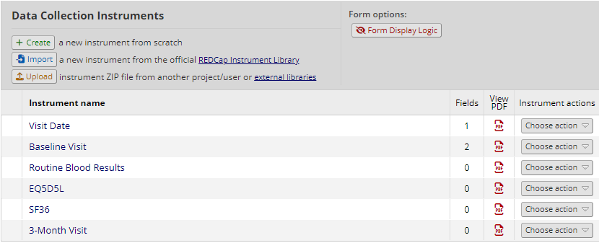

The function is enabled in a similar way to Branching Logic, by selecting the form you wish to apply the Form Display Logic to and specifying the logic under which this will occur:

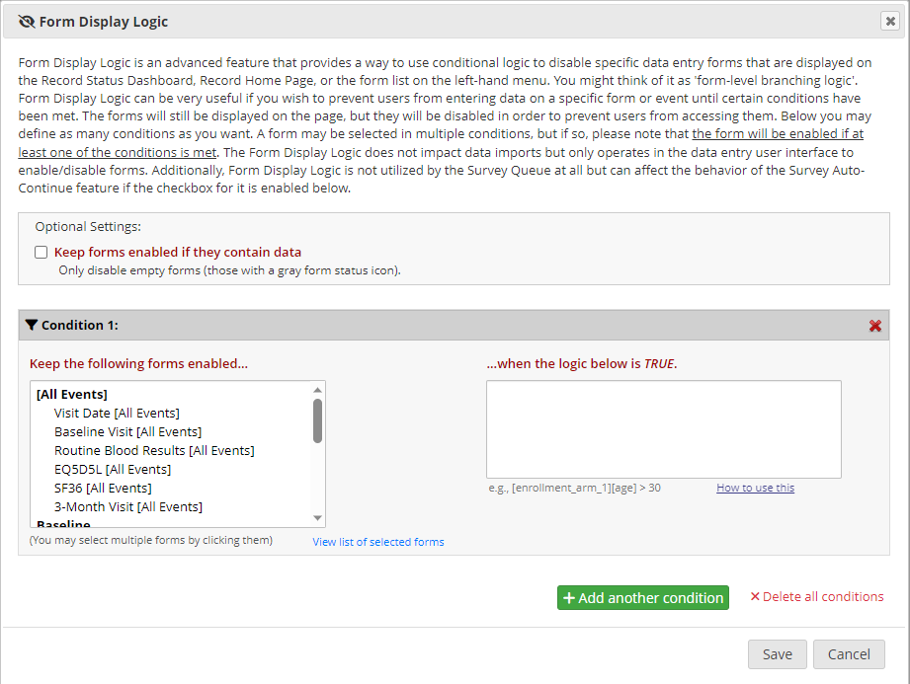

|  |
| --- |
| **External Randomisation via API token** |

If using a randomisation via the API, two instruments should be implemented in the appropriate event (you may choose to create a specific Randomisation event itself) to facilitate this.

The first instrument will contain the field used to initiate the randomisation (‘Randomise Now?’ radio button with Yes/No response) as well as the date and time of randomisation fields.

Branching Logic should be used so that the ‘Randomise Now?’ button only appears once all inclusion/exclusion and variables for randomisation (e.g. any minimisation or stratification fields) are completed as required.

The randomisation date and time fields should be programmed using the calctext function to allow autopopulation of this data.

If the study in unblinded, the second instrument will contain a hidden drop-down field with the randomisation options as well as descriptive alert fields to display the result once retrieved by the API. Branching Logic should be used to allow these alerts to appear depending on the result that is imported into the hidden field.

Once the required events and instruments have been implemented, use the instructions in ECTU Central Office SOP ECTU_SOP_REDCap 12 Assigning Access to the REDCap API to generate the API token.

The external randomisation system will be set-up by a Senior Software Developer. They should be provided with the protocol which states the randomisation requirements as well as the database and field information specified in then above SOP in order to set this up.

The Senior Software Developer will liaise with the Trial Statistician or Unblinded Statistician or designee to review and approve the external system.

|  |
| --- |
| **REDCap Randomisation** |

The REDCap randomisation module is rarely used. This should only be used where simple randomisation is required and the project is not blinded. This system is only suitable when the parameters of the study are clearly defined and not expected to change (e.g. the study will not add extra sites or significantly increase the sample size)

To implement this, enable the Randomisation module on the ‘Project Setup’ page:

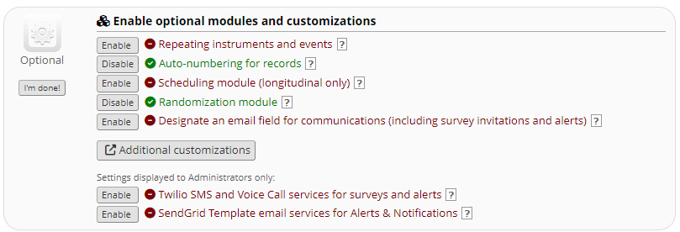

The ‘Randomisation’ application will then be available for set-up. Follow the steps in Step 1 to define the randomisation module:

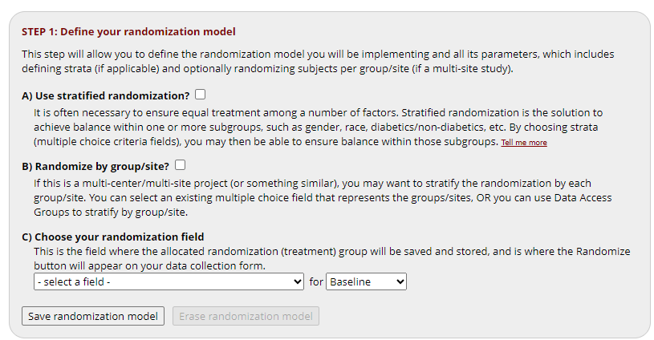

Once completed and saved, Step 2 and 3 can be utilised.

Step 2 allows you to download a template that can be used to produce a randomisation list (to be provided by a Senior Software Developer or Trial Statistician – separate lists for training and live study database)

Once you have received the randomisation list, this can be uploaded in Step 3.

|  |
| --- |
| **Surveys** |

Two types of surveys can be used – front facing surveys where a web link is placed somewhere for participants to access and sign up themselves and automated survey invitations which are sent once data has been entered on REDCap. Automated surveys require a participant email address to be held in the database so these can be sent.

Surveys are enabled at the top of the ‘Project setup’ page by selecting ‘Use surveys in this project’. You can then select which instruments should be enabled as a survey on the ‘Online Designer’ page.

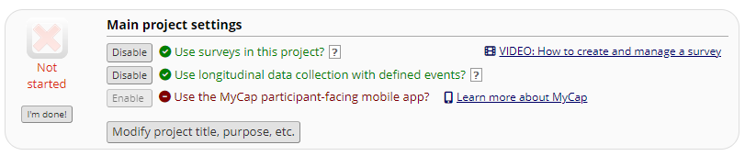

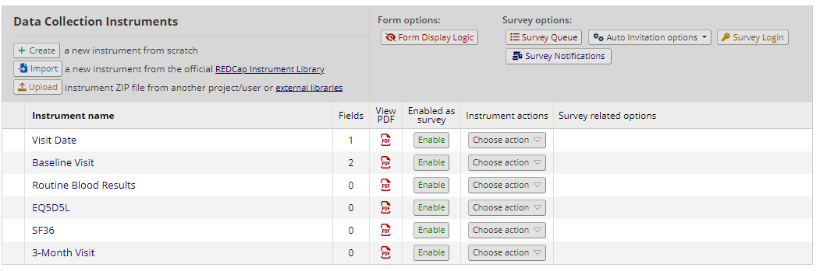

Selecting ‘Enable’ for the survey will display the ‘Survey Settings’ page.

Edit the Survey Title, Survey Instructions and Survey Design Options as appropriate. Edit the Survey Customisations section as appropriate. It is recommended that ‘Question Numbering’ is changed to ‘Custom numbered’. Select the appropriate email field for the ‘Survey-specific email invitation field’ response.

If multiple surveys are completed, select ‘Auto-continue to next survey’. This would be appropriate if the participant is completing a set of questionnaires that have been split in to multiple instruments, e.g. EQ5D5L, SF-36. If all are completed at a visit, select this option so the participant is automatically directed to the next questionnaire. All must be enabled as a survey for this option to work.

To generate the automated invitations, select the ‘Automated Invitations’ tab on the Online Designer and click ‘Set up’ for the appropriate time point. All visits where that instrument is completed will appear but the survey may only need to be sent at specific visits, e.g. 6 months and 12 months. Choose as appropriate.

Ensure the automated invitations are set to ‘Active’.

Select who the email will send from. It is recommended that this is a generic trial email address. Participants may respond with questions so it’s most appropriate they are directed to the Trial Office. The generic email address should be added as a user to REDCap. Add the user with a custom role and remove access to everything in the project, e.g. remove access to create records, remove access to all instruments. This is to ensure no one edits or adds data using a generic account which would negatively impact the audit trail. The user can also be suspended so that no attempt to log-in can be made with this username. Notify the TM that this user role has been set-up for notification purposes only and that it is not necessary to log-in using this username.

Edit the Subject Line as appropriate. The TM should provide REC approved text to be included in the email text section. This **must** include [survey-link] and/or [survey-url] so the participant can access the survey.

Specify the conditions for sending the invitation. In most situations, the second option ‘When the following logic becomes true’ will be the condition used. At a minimum, a check will be needed that the participant wishes to receive their questionnaires by email (there should be a specific field in an appropriate instrument for this) and that the questionnaire will be sent at the correct time (e.g. Date of Randomisation + 90 Days). There should also be checks on the participant’s status, e.g do not send future questionnaires if the participant has withdrawn.

Select the tickbox for ‘Ensure logic is still true before sending invitation’

Select when the invitation will send from the options listed.

Select when a reminder is sent. This may be stated in the protocol or the Trial Manager or appropriate study designee will advise.

|  |
| --- |
| **Additional Functions** |

The ‘Additional Customisations’ section of the ‘Project Set-up’ page allows further functionality to be added to the database:

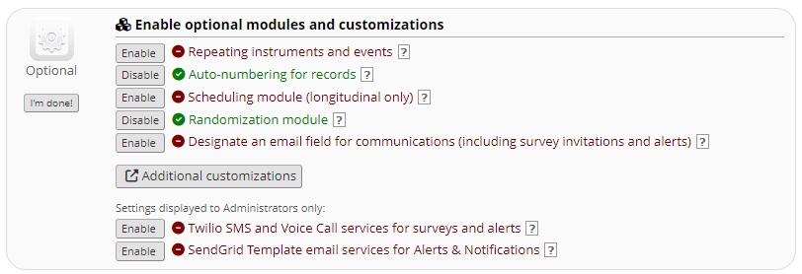

The most commonly used customisations are as follows:

**‘Enable the Field Comment Log or Data Resolution Workflow (Data Queries)?’** – Enabling this option and setting to ‘Data Resolution Workflow’ opens the Data Quality application. This allows data quality rules to be implemented to query data and resolve issues on the database.

**‘Enable the Data History popup for all data collection instruments’** – This displays a history icon next to each data entry field, allowing previous entries to be viewed.

**‘Display the Today/Now button for all date and time fields on forms and surveys’** – This allows a button to automatically populate the field with the current date/time

**‘Require a reason when making changes to existing records?’** – Any time a change is made to an already saved instrument, a reason for this change should be provided. This is a requirement from ACCORD for all CTIMP/risk-assessed studies.

**‘Data Entry Trigger’** – this field must be enabled and the url entered when using an API randomisation (see ECTU_SOP_REDCap_12 for details)

|  |
| --- |
| **Useful Resources** |

**ECTU REDCap SOPs**

The Data Management Team have developed a suite of SOPs which describes the process for building, maintaining and releasing a REDCap study database. These are available on the ECTU shared drive U:\Datastore\CMVM\mvmsan\collegeoffice\ECT Unit\SOPs\Finalised SOP and WPD\REDCap

**The Data Management team have a selection of databases that can be referred to assist in a database build:**

**Date Diff – REDCap Database PID 173** – this gives a variety of examples using the datediff function which allows calculations between date fields

**HTML Examples – REDCap Database PID 183** – formatting and appearance examples including fonts, progess bars etc.

**REDCap Build Training & Best Practice- REDCAP Database PID 437** – examples of commonly used instruments and functions for most databases. The instruments include formatting, branching logic and calculations

REDCap Administrators can access any database on the REDCap platform to refer to when completing a build. Be sure to access the **TRAINING** version of the database for reference.

<<<<<<<<<For document control only. Remove this page from final version>>>>>>>>

|  |  |  |  |
| --- | --- | --- | --- |
| **Document Revision History** | | | |
| **Version No** | **Effective Date** | **Revised By (Name and Designation)** | **Summary of Revisions** |
| 1.0 | 20-June-2024 | Lynsey Milne, Data Manager | * Initial creation/New document |