### Example 1. Title Page

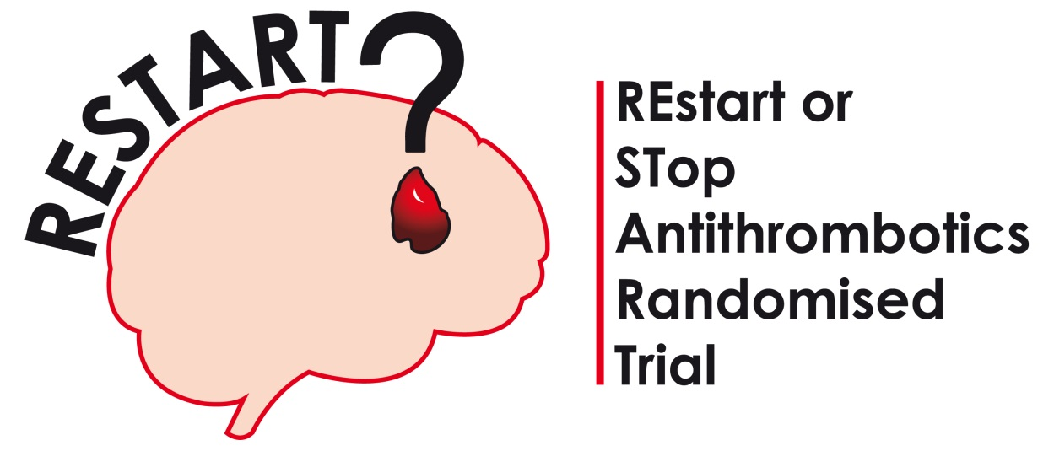

Restart or Stop Antithrombotics Randomised Trial

Interim Report for the Data Monitoring Committee

(OPEN REPORT)

Version: XX

Date report produced: XXX

Report produced by: xxx, Unblinded Statistician

Protocol Version: XX (Date XX)

This report is based on the trial database as it was on: XX

The most recent participant included in this report was randomised on: XX

### Example 2. Trial Summary/Flow Chart

Trial Summary

|  |  |
| --- | --- |
| **Trial Design** | The RESTART trial is an investigator-led, multicentre, randomised, open, assessor-blind, parallel group clinical trial of investigational medicinal product (CTIMP) prescribing strategies in standard care at multiple hospitals in the National Health Service (NHS) in the United Kingdom. |
|  |  |
| **Interventions** | Start antiplatelet drug(s) (one or more of aspirin, clopidogrel, or dipyridamole, chosen by patient’s physician pre-randomisation) *versus* avoid antiplatelet drug(s). |
|  |  |
| **Participants** | Adults surviving spontaneous (non-traumatic) intracerebral haemorrhage (ICH) who had taken an antithrombotic (i.e. anticoagulant or antiplatelet) drug for the prevention of vaso-occlusive disease before the ICH. |
|  |  |
| **Eligibility criteria** | Participants (aged 18 years or older) and their doctors are uncertain about whether to start or avoid antiplatelet drugs at least 24 hours after ICH symptom onset. |
|  |  |
| **Primary Research Question** | For patients who develop spontaneous (non-traumatic) intracerebral haemorrhage (ICH) while taking antithrombotic drugs for the prevention of vaso-occlusive disease, it is unclear whether survivors of ICH should start antiplatelet drugs for continued secondary prevention of vaso-occlusive disease or avoid antiplatelet drugs in case it increases the risk of extracranial and intracranial haemorrhage. The primary research question is: *Does a policy of starting antiplatelet drugs result in a beneficial net reduction of all serious vascular events over at least two years compared with a policy of avoiding antiplatelet drugs?* |
|  |  |
| **Primary outcome measure** | Recurrent symptomatic ICH (fatal or non-fatal, radiographically- or pathologically-proven) |
|  |  |
| **Secondary outcome measures** | * Fatal (i.e. followed by death within 30 days) or non-fatal (i.e. not followed by death within 30 days) serious vascular events: symptomatic haemorrhagic events, symptomatic vaso-occlusive events, symptomatic stroke of uncertain sub-type. * Other fatal events: Deaths without a clear cause and without further investigation, deaths from any other cause. * Annual ratings of participant function completed by participant or their carer: simplified modified Rankin Scale postal questionnaire, structured telephone interview with non-responders to the postal questionnaire. |
|  |  |
| **MRI Sub-study** | The aim of the brain MRI sub-study is to test for an interaction between the presence of brain microbleeds(which are diagnostic and prognostic radiographic biomarkers) and the effects ofantiplatelet drugs and explore whether there is a trend in the risk of recurrent ICH with increasing numbers of microbleeds. TheMRI must be performed after the ICH but before randomisation for a patient to be eligible for the MRI Sub-study. |
| **Stepped Wedge Trial** | Trial methodology is being assessed with an opt-in, cluster-randomised, stepped wedge trial at a sub-group of 72 RESTART sites, to assess the effects of an intervention to manage the performance of sites to fulfil the recruitment targets they set at their site initiation visit. This trial started in September 2015. |
| **TICH-2 Co-enrolment** | A proportion of patients recruited to RESTART may also be enrolled in the Tranexamic acid for hyperacute primary IntraCerebral Haemorrhage (TICH-2) trial, assessing the intervention of intravenous tranexamic acid. |
|  |  |
| **Trial Start date** | May 2013 |
|  |  |
| **Trial End date** | BHF funding ends January 2018 |
|  |  |
| **Target Sample Size** | At least 720 participants in the main trial (at least 550 in the MRI sub-study). |
|  |  |
| **Follow-up** | A minimum of two years follow-up for all patients |
|  |  |
| **Sample size calculation from the protocol (version 6, page 28)** | This pilot study of 720 patients will have excellent power (after all participants have been followed for at least two years) to detect a doubling of the rate of ICH if the true rate is 4.5% per annum, but there would be 93% power at the 5% significance level to detect a 4-fold increase in risk of recurrent ICH if the annual risk is only 1%. |
|  |  |
| **Interim analyses (as written in the DMC Charter)** | Interim analyses of un-blinded data will be based on survival analyses over two years of follow-up from randomisation of (1) the primary outcome, and (2) all serious vascular events (in order to assess the plausibility of a net benefit emerging in a larger main study). In the light of these analyses, the DMC will advise the chair of the TSC and Sponsor (via the chief investigator) if, in their view, the randomised comparisons in RESTART have provided both (i) “proof beyond reasonable doubt” that for all, or for some, specific types of patient, antiplatelet drugs are clearly indicated or clearly contraindicated, and (ii) evidence that might reasonably be expected to materially influence future patient management by many clinicians who are already aware of the results of any other relevant trials. |
|  |  |
| **Stopping rules (as written in the DMC Charter)** | The DMC will work on the principle that a difference of **at least 3 standard errors** between groups in an interim analysis of the primary outcome is needed to justify halting, or modifying, a study before the planned completed recruitment. |

Trial Flow Chart

**Annual:** central follow-up via both participant and their general practitioner

**Annual:** administrative data (flagging and hospital admissions)

No outcome

Participant questionnaire

Outcome

Local follow-up via CRN

No outcome

Outcome

Participant questionnaire

Alive

Dead

Dead

Alive

**Hospital/clinic discharge:** local follow-up form, central prompt to participant

**START antiplatelet drug(s)**(one or more of aspirin, clopidogrel, or dipyridamole, chosen by patient’s physician pre-randomisation)

**AVOID antiplatelet drugs**

**Randomise**

Collect baseline data

Obtain consent (fax to co-ordinating centre and copy to GP)

Check eligibility

Identify patient with ICH

*Annually (for at least two years)*

*Annually (for at least two years)*

Perform brain MRI if in sub-study

### Example 3. Summary of Recruitment.

Table. Summary of Recruitment

|  |  |
| --- | --- |
|  | Main Study |
| Date First Randomised Patient | XX |
| Date Recruitment Stopped | XX |
| **Recruitment Target for June 2015** | **XX** |
| **Number of Patients Randomised** | **XX (XX%)** |
| Total number of sites | XX |
| Number of sites that have randomised patients | XX |
| Recruitment in last quarter | XX |

Figure. Site activation graph

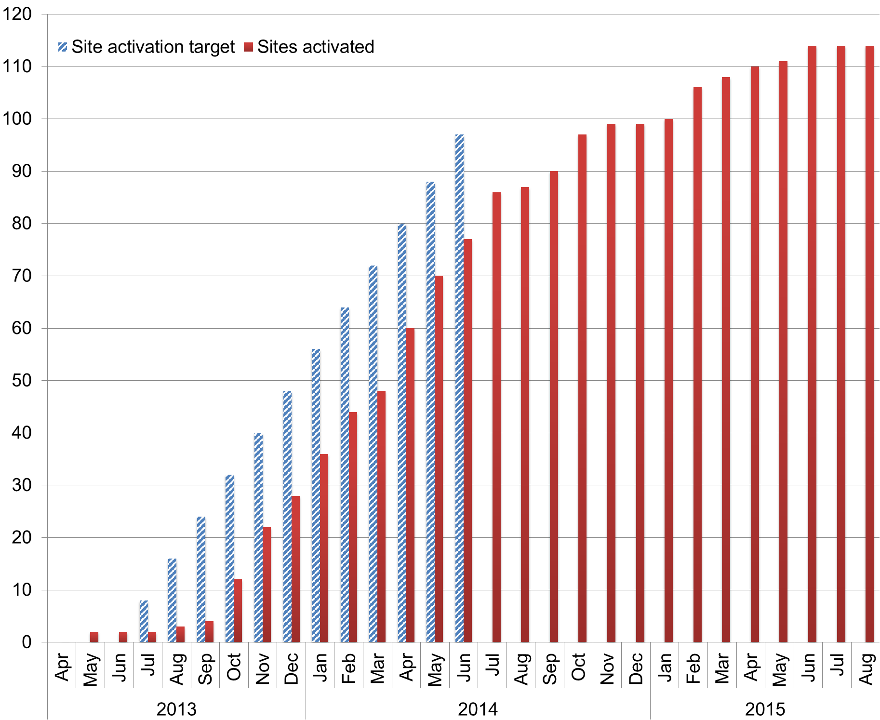

Figure. Recruitment graph

Note. Estimated recruitment is based on rates in the original grant application.

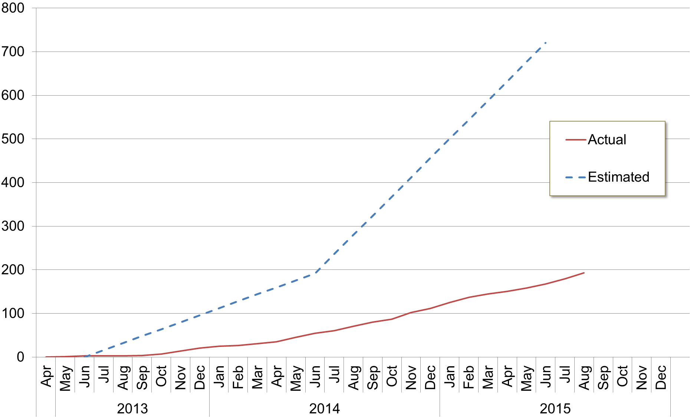

Table. Numbers screened, eligible and randomised by study centre.

|  |  |  |  |  |
| --- | --- | --- | --- | --- |
|  | Screened | Potentially Eligible | Randomised | Not Recruited |
| Study Centre | n (%) | n (%) | n (%) | n (%) |
| XXX | X (X) | X (X) | X (X) | X (X) |
| XXX | X (X) | X (X) | X (X) | X (X) |

Table. Recruitment history by study centre. Table is ordered by average monthly recruitment rate.

| Study Centre | City | Total recruited | Total months in trial | Average Monthly Recruitment Rate | Number recruited in the last quarter | Days since last randomisation |
| --- | --- | --- | --- | --- | --- | --- |
| XXX | XXX | XX | XX | XX | XX | XX |

### Example 4. Baseline balance.

Table. Demographic characteristics and risk factors at randomisation.

|  |  |  |  |  |
| --- | --- | --- | --- | --- |
|  |  | **Active** |  | **Placebo** |
| Characteristic | **No.** | **(%)** | **No.** | **(%)** |
| **Age*:** 36 to 67 | XX | (XX%) | XX | (XX%) |
| **(years)** 68 to 75 | XX | (XX%) | XX | (XX%) |
| 76 to 102 | XX | (XX%) | XX | (XX%) |
| mean (s.d.) | XX | (XX) | XX | (XX) |
| **Sex*:** Female | XX | (XX%) | XX | (XX%) |
| Male | XX | (XX%) | XX | (XX%) |
| **Diastolic BP:** 15 to 75 | XX | (XX%) | XX | (XX%) |
| **(mmHg)** 76 to 84 | XX | (XX%) | XX | (XX%) |
| 85 to 130 | XX | (XX%) | XX | (XX%) |
| Unknown | XX | (XX%) | XX | (XX%) |
| mean (s.d.) | XX | (XX) | XX | (XX) |

*Highlight minimisation/stratification factors

### Example 5. Data Completeness.

Table. Trial randomisation flow chart.

|  |  |  |  |
| --- | --- | --- | --- |
| **Patients randomised** (n=XX) | **Active** (n=XX) |  | **Placebo** (n=XX) |
|  |  |  |  |
| **Received Discharge form** Yes | XX |  | XX |
| No | XX (XX%) |  | XX (XX%) |
| Reasons for not having form: |  |  |  |
| Pending [XX of these have been received but not yet entered] | XX |  | XX |
| *been due for 0 to 3 months* | *XX* |  | *XX* |
| *been due for 3 to 6 months* | *XX* |  | *XX* |
| *been due for 6 months to 1 year* | *XX* |  | *XX* |
| *been due for >1 year* | *XX* |  | *XX* |
|  |  |  |  |
| **Followed up at 30 days (doctor follow up)** | XX |  | XX |
| Died before 30 days: | XX |  | XX |
| Not followed up: | XX (XX%) |  | XX (XX%) |
| Reasons for not following up: |  |  |  |
| Patient refused | XX |  | XX |
| Patient died at >30 days, before follow up done | XX |  | XX |
| Pending | XX |  | XX |
| *been due for 0 to 3 months* | *XX* |  | *XX* |
| *been due for 3 to 6 months* | *XX* |  | *XX* |
| *been due for 6 months to 1 year* | *XX* |  | *XX* |
| *been due for > 1 year* | *XX* |  | *X* |
| *Not due yet:* | *XX* |  | *XX* |
|  |  |  |  |
| **Followed up at 30 days (patient follow up - UK only)** | XX |  | XX |
| 1 year follow up instead: | XX |  | XX |
| No QOL, but major endpoints from GP: | XX |  | XX |
| Died before 30 days: | XX |  | XX |
| Not followed up: | XX (XX%) |  | XX (XX%) |
| Reasons for not following up: |  |  |  |
| Patient too ill / refused | XX |  | XX |
| Patient died at >30 days, before follow up done | XX |  | XX |
| Pending | XX |  | XX |
| *been due for 0 to 3 months* | *XX* |  | *XX* |
| *been due for > 1 year* | *XX* |  | *XX* |
| *Not due yet:* | *XX* |  | *XX* |
|  |  |  |  |
| **Followed up at 1 year** | XX |  | XX |
| Died before 1 year: | XX |  | XX |
| Not followed up: | XX (XX%) |  | XX (XX%) |
| Reasons for not following up: |  |  |  |
| Patient refused | XX |  | XX |
| Pending | XX |  | XX |
| *been due for 0 to 3 months* | *XX* |  | *XX* |
| *been due for 3 to 6 months* | *XX* |  | *XX* |
| *been due for 6 months upwards* | *XX* |  | *XX* |
| *Not due yet:* | *XX* |  | *XX* |

Table. Study Visit Number XX Attended and Questionnaires Completed

|  |  |  |  |  |  |
| --- | --- | --- | --- | --- | --- |
|  | Randomised Treatment | | | | |
|  | Active | |  | Placebo | |
|  | N | % |  | N | % |
| Total No. of Patients Randomised | XX | XX |  | XX | XX |
| Did patient attend Study Visit Number XX | XX | XX |  | XX | XX |
| Missing | XX | XX |  | XX | XX |
| Patient attended for visit | XX | XX |  | XX | XX |
| Patient did not attend | XX | XX |  | XX | XX |
| Visit not due yet | XX | XX |  | XX | XX |
| Early withdrawal | XX | XX |  | XX | XX |
| Withdrawn by Clinician | XX | XX |  | XX | XX |
| Lost to Follow-Up | XX | XX |  | XX | XX |
| Deceased | XX | XX |  | XX | XX |
| Early withdrawal after primary endpoint reached | XX | XX |  | XX | XX |
| Early withdrawal due to an AE | XX | XX |  | XX | XX |

### Example 6. Adherence.

The following protocol deviations were reported:

| **Centre Name** | **Deviation date** | **Description of Deviation** |
| --- | --- | --- |
| XX | XX | XX  Corrective Action:  XX  Preventative Action:  Xx |

Note. Highlight new deviations from previous reports.

Table. Adherence to treatment allocation.

|  |  |  |  |  |
| --- | --- | --- | --- | --- |
|  | Group | | | |
|  | Active | | Placebo | |
| Number of patients randomised | XX |  | XX |  |
| *Discharge form pending* | *XX* |  | *XX* |  |
| Received treatment as allocated | XX | (XX%) | XX | (XX%) |
| Did not receive treatment as allocated | XX | (XX%) | XX | (XX%) |
| Reasons: |  |  |  |  |
| No treatment given | XX |  | XX |  |
| Cross-overs (other treatment used) | XX |  | XX |  |

Table. Adherence to dose allocation

|  |  |  |  |  |  |
| --- | --- | --- | --- | --- | --- |
|  | Randomised Treatment | | | | |
|  | Active | |  | Placebo | |
|  | N | % |  | N | % |
| Total No. of Patients Randomised | XX | XX |  | XX | XX |
| **Dose Changes** |  |  |  |  |  |
| Dose decreased | XX | XX |  | XX | XX |
| Dose stayed same | XX | XX |  | XX | XX |
| Dose increased | XX | XX |  | XX | XX |
| Trial Medication Stopped | XX | XX |  | XX | XX |
|  |  |  |  |  |  |
| Reasons for Stopping Trial Medication |  |  |  |  |  |
| Adverse Event | XX | XX |  | XX | XX |
| Blood Test Result | XX | XX |  | XX | XX |

### Example 7. Outcomes

The primary outcome is XXX.

Table. Number of Primary Outcome Events.

|  |  |  |  |  |  |
| --- | --- | --- | --- | --- | --- |
|  | Randomised Treatment | | | | |
|  | Active | |  | Placebo | |
|  | N | % |  | N | % |
| Total No. of Patients Randomised | XX | XX |  | XX | XX |
| **Primary Endpoint** |  |  |  |  |  |
| No | XX | XX |  | XX | XX |
| Yes | XX | XX |  | XX | XX |

Figure. Cumulative interim analyses results for primary outcome measure



### Example 8. Safety

For patients who had a SUSAR they would be unblinded by ACCORD to determine whether the patient was on active treatment or placebo for reporting to the MHRA.

Table. List of SUSARs

|  |  |  |  |  |
| --- | --- | --- | --- | --- |
| Patient ID | Centre | Randomised Treatment | Reason | Explanation |
| XX | XX | XX | XX | XX |
|  |  |  |  |  |

Table. List of Serious Adverse Events

Treatment = Active

|  |  |  |  |  |  |  |  |  |  |
| --- | --- | --- | --- | --- | --- | --- | --- | --- | --- |
| Patient ID | SAE Number | Randomi-sation Date | Event | Date of Event | Related to Treatment | Expected | Outcome | Date of Recovery | Date of Death |
| XX | XX | XX | XX | XX | XX | XX | XX | XX | XX |
|  |  |  |  |  |  |  |  |  |  |

Treatment = Placebo

|  |  |  |  |  |  |  |  |  |  |
| --- | --- | --- | --- | --- | --- | --- | --- | --- | --- |
| Patient ID | SAE Number | Randomi-sation Date | Event | Date of Event | Related to Treatment | Expected | Outcome | Date of Recovery | Date of Death |
| XX | XX | XX | XX | XX | XX | XX | XX | XX | XX |
|  |  |  |  |  |  |  |  |  |  |

**This page should be removed from the study specific version**

|  |  |  |
| --- | --- | --- |
| Template Revision History | | |
| Version No | Date | Summary of Revisions |
| 1.0 | 13 Mar 2017 | Initial Creation |
| 2.0 | 18 Feb 2020 | Unknown |
| 3.0 | 16 June 2022 | Addition of Template Revision History page. Reviewed during periodic review of ECTU_WPD_ST_W3, no other updates required. |
| 4.0 | 06 Dec 2023 | Reviewed during periodic review of ECTU_SOP_ST_03 Data Monitoring Committee. No updates required. |