ECTU Work Instruction #6
Title: Merchandise and study incentives  V2.0 06 December 2023 | Last updated: 06 December 2023

Name | Signature | Date
Authored by: | Annabel Giddings
Reviewed by: | Claire Battison
Approved by:

1. PURPOSE
This Work Instruction (WI) provides guidance and suggestions on study merchandise and study incentives/ gifts/competitions for sites.

2. SCOPE

This WI applies to studies within ECTU with an assigned Trial Manager who will be responsible for overseeing the management of the trial.

3. BACKGROUND
To help promote the trial and to encourage recruitment at sites, the trial management team may consider sending study merchandise and incentives to sites.
4. RESPONSIBILITIES
Trial Manager or designee (e.g Assistant Trial Manager, Trial Management Support Officer)
5. PROCEDURE (INSTRUCTIONS AND GUIDANCE)
Ideas for site incentives / competitions:
- First site to consent/randomise a participant by (insert date)
- Site with the highest number of participant by (insert date)/in XX quarter
- Site with the most complete database/no queries in the database by (insert date)
- Picture competition (pictures will be published in the newsletter
- Christmas & Easter chocolates/cards for sites and patients

- First site to reach XX% of their target recruitment.
- Site that randomises a milestone number e.g., the 20th participant
- Prize for final participant visit or completed data entry

Ideas for site prizes and study promotional materials:
- Pens
- Post-its
- Coasters
- Tote bags
- Coffee / vending cups
- Lanyards
- Chocolates
- Food Hampers

Recommended University of Edinburgh approved providers:

Study branded merchandise:
Total Merchandise https://www.totalmerchandise.co.uk/

Email: info@totalmerchandise.co.uk

- Email info@totalmerchandise.co.uk with order request (e.g 100 branded cups) with study logo attached (send as an EPS file or AI file), and request a quote and pre-order visuals.
- Total Merchandise will issue a quote and send pre-order visual (PDF).
- Confirm the order is correct with Total Merchandise. Total Merchandise may ask for further details (e.g delivery address, contact number) before confirming the order.
- Total Merchandise will send a Sales Order Confirmation.
- Request a Purchase Order number from ECTU business team and send to Total Merchandise. The order will then be released and delivered.

Other suggested study branded merchandise providers:

4imprint UK
https://www.4imprint.co.uk/
Email: sales@4imprint.co.uk
Tel: 0800 055 6196

Allwag Branded Merchandise

https://www.allwag.co.uk/
email: sales@allwag.co.uk
Tel:01245382600

For gifts / prizes: Suggested company is PPD (Highland Fayre)
Order process for PPD (Highland Fayre):
Contact person is: Stacie-Ann stacieann@highlandfayre.co.uk
- ECTU contact Stacie-Ann to request either a Treat box or Biscuit option (see details below) providing details of number of boxes, contact person, delivery address and phone number, delivery date and any gift message with trial logo.
Or you can request a different option from Stacie-Ann. Review the highland fayre website for options and prices. https://www.highlandfayre.co.uk/
- Highland Fayre will issue the quote/ invoice
- ECTU receive invoice and ask Business team to raise a PO and confirms which grant is to be used
- 4.Once PO received email to Highland fayre in order for them to raise invoice with a PO number
- Provide the Business team with the Invoice containing the PO number
- Highland Fayre send out goods with gift message to the recipient(s)
Examples of gifts from Highland fayre:
ECTU Treat Box 2023 - £20.00 including VAT & delivery
Arden's Tiny Cheese Twists, little flaky puff pastry twists baked with cheddar cheese (75g) Fairfields Farm Sea Salt & Black Pepper flavoured Handcooked Potato Crisps (150g) Duncan's of Deeside All Butter Salted Caramel Scottish Shortbread (150g) Taylor's Sweet & Salted Popcorn (100g) Pergale Milk Dessert Flavoured Chocolate Assortment with Smooth Fillings (113g) Presented in a Star Design Gift Carton
Biscuit Option - £12.00 including VAT & delivery
Border Biscuits Classic Made For Sharing Biscuit Selection - Shortbread Rings, Butterscotch Crunch, Sultana Melts, Chocolate Cookies, Milk Chocolate Oat Crumbles & Chocolate Viennese Whirls (400g)
For other approved University providers check: https://uoe.sharepoint.com/sites/Procurement2

You should always aim to use University approved suppliers. If in doubt, ask the ECTU business team or Senior Trial Managers

Examples of study merchandise / prizes to send to sites:


https://www.totalmerchandise.co.uk/branded-products/promotional-pens-and-writing/super-hit-ballpen

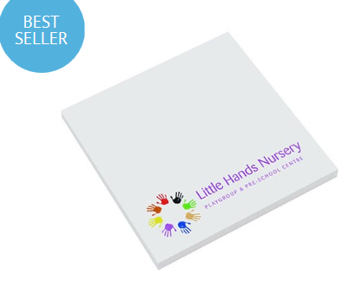
https://www.totalmerchandise.co.uk/branded-products/promotional-paper-products/sticky-notes-3x3

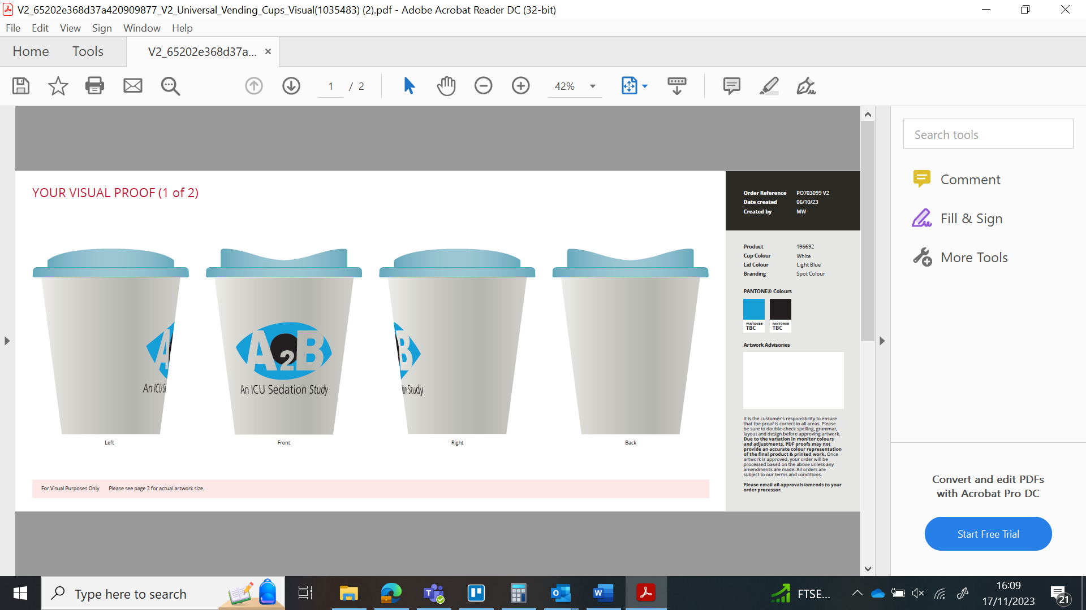

https://www.totalmerchandise.co.uk/branded-products/promotional-mugs-and-drinkware/universal-vending-cups

Examples of picture competitions:
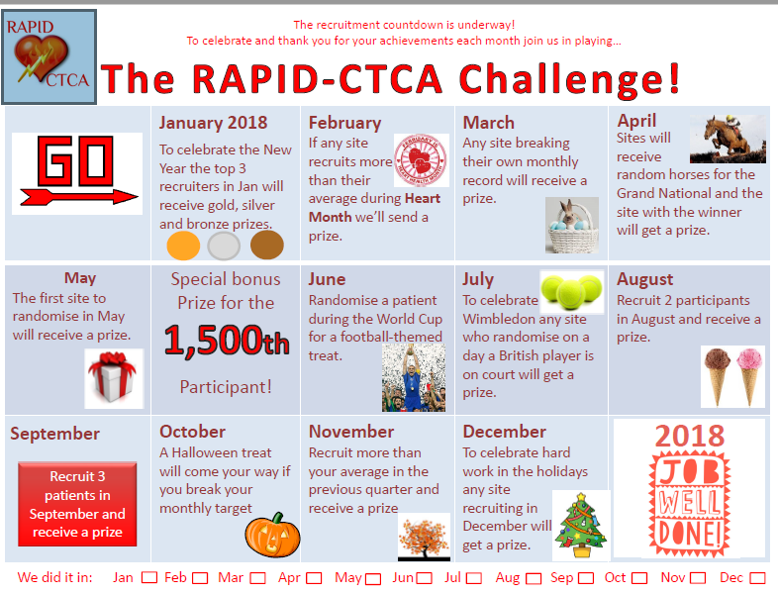

6. RELEVANT DOCUMENTS /APPENDICES

