
<<Study Name>>
Training and Description document

[Sections in red must be removed/ edited]

Feature Information:
Feature No. | Feature description | Feature Version | Design Specification
000 | Participant Details | 1.0

Signature/ Training Declaration:
Date Undertaken | Name and Signature | Project Role
DD MMM YYYY | [Enter Validator details]

Document History:
Date | Version Author(s) and project roles | Reason
DD MMM YYYY |  | - Initial creation  - Feature version set to 1.0

Purpose:
This document has three purposes.
- It describes the process of managing Participants.
- It describes the screens and functionality provided to perform this task in enough detail that users can test the functionality of the system against the description here.
- It provides a Training Declaration so the document contributes to the training record for the study.

[Enter screen shots where applicable]

Step 1 – Login with Administrator credentials
- Click the Login link at the top right of the page.
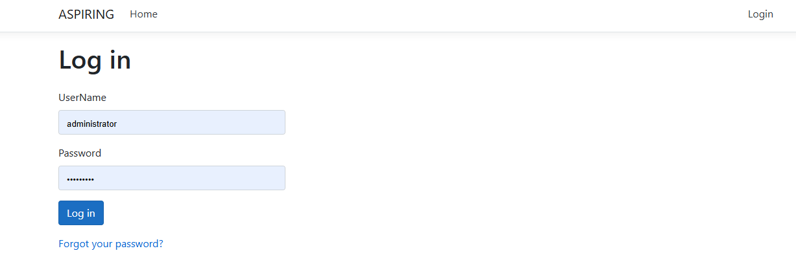
- Enter your credentials.

Step 2 – Participant
- Select the Participant menu option. The Participant Details screen is displayed.

<<<<<For template control only. Remove this page from study specific version>>>>>>

Template Revision History
Version No | Date | Summary of Revisions
1.0 | 31 May 2018 | Initial Creation/new document
2.0 | 09 Mar 2026 | Added to the QMS, updated footer and identifier added. Minor formatting changes

